**Classroom Activity: Create a portfolio website to showcase their educational background, personal achievements, and project work.**

**Code: How to add Heading or Main title on web Page**

|  |
| --- |
| <h1> Karan Bhat Portfolio </h1> |

**Output:**

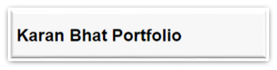

**Code: How to add text or paragraph on the web page**

|  |
| --- |
| <p>Karan Bhat is a skilled technical trainer with extensive experience in teaching and mentoring. He specializes in various programming languages and web development technologies. Known for his clear explanations and practical approach, Karan has successfully guided many students through complex technical concepts. His passion for technology and dedication to student success make him a valuable asset in the educational field. Karan continuously updates his knowledge to provide the most current and relevant training to his students.</p> |

**Output:**



**Code: How to add a list of content on the web page**

|  |
| --- |
| <ul>  <li><a href="index.html">Home</a></li>  <li><a href="portfolio.html">Portfolio</a></li>  <li><a href="contact.html">Contact</a></li>  <li><a href="about.html">About</a></li>  </ul> |

**Output:**

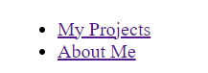

**Code: How to add an image on the web page**

|  |
| --- |
| <figure>  <img src="images/pexels-pixabay-301920.jpg" width="400px" height="200px" alt="Study">  <figcaption>Karan Do Hard Work Please</figcaption>  </figure> |

**Output:**



**Code: How to add a video on the web page**

|  |
| --- |
| <video controls>  <source src="videos/2278095-hd_1920_1080_30fps.mp4" type="video/mp4">  Your browser does not support the video tag.  </video> |

**Output:**

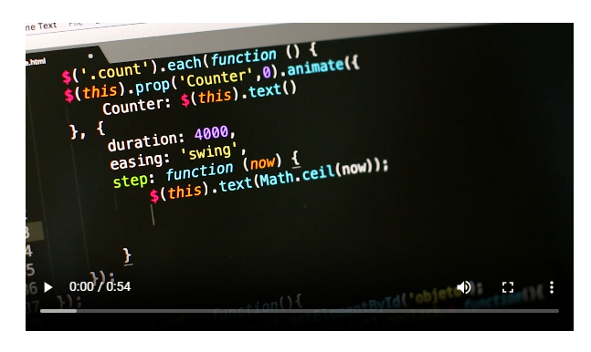

**Code: How to add a table on the web page**

|  |
| --- |
| <table>  <caption>Academic Qualifications</caption>  <thead>  <tr>  <th>Qualification</th>  <th>Percentage/CGPA</th>  </tr>  </thead>  <tbody>  <tr>  <td>10th</td>  <td>60%</td>  </tr>  <tr>  <td>12th</td>  <td>60%</td>  </tr>  <tr>  <td>B.E. Computer Science</td>  <td>6.2 CGPA</td>  </tr>  </tbody>  </table> |

**Output:**

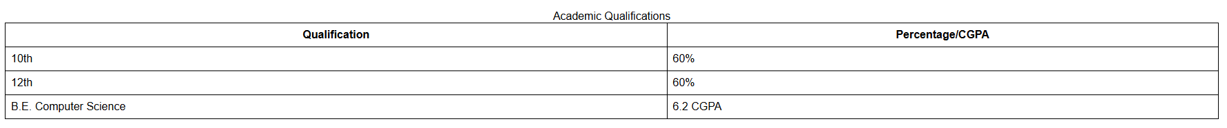

**Code: How to add a form on the web page**

|  |
| --- |
| <form action="submit_form.php" method="post">  <label for="name">Name:</label>  <input type="text" id="name" name="name">  <br>  <label for="message">Message:</label>  <textarea id="message" name="message"></textarea>  <br>  <br>  <button type="submit">Submit</button>  <br>  </form> |

**Output:**

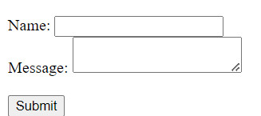

**Code: How to add a Blockquote on a web page**

|  |
| --- |
| <blockquote>  "Karan Bhat is a technical trainer working at Edunet Foundation as a Master Trainer."  <cite>Edunet Foundation</cite>  </blockquote> |

**Output:**



**Execution Steps:**

* Step 1: Set Up Your Project Directory
* Open Visual Studio Code.
* Create a new folder for your project, e.g., PortfolioProject.
* Step 2: Create the file name eg.)Portfolio.html
* Write a code for the Heading, Text, Paragraph, List, Image, Video, Table, and form.
* Step 3: Click on Go Live.
* Step 4: Then it automatically takes up to the browser page.
* Step 5: Select Inspect
* Step 6: Get the idea of the code.